Quality of Software

Definition:
# Source: AI Source: Provided by: [Data Path: Persons Table -> ID Column: 1, Name_En Column: Motasem Essam] -> From: [ChatGPT] on [8/21/2025]
The quality of software is the degree to which a software product meets its requirements, user expectations, and industry standards while being reliable, maintainable, efficient, and usable.
In simple terms → “Good quality software does what it is supposed to do, works well, is easy to use, and can be maintained and extended without major issues.”

🔹 Key Characteristics of Software Quality
# Source: AI Source: Provided by: [Data Path: Persons Table -> ID Column: 1, Name_En Column: Motasem Essam] -> From: [ChatGPT] on [8/21/2025]
(Defined by standards like ISO/IEC 25010 and IEEE)
- Functionality – The software provides the required features and functions correctly.
  - Example: A banking app correctly transfers money.
- Reliability – The software performs consistently under defined conditions without failure.
  - Example: ATM software doesn’t crash when multiple users access it.
- Usability – Easy to learn and use, with a good user interface (UI/UX).
  - Example: A new user can quickly learn to use a ride-hailing app.
- Efficiency (Performance) – Uses system resources (CPU, memory, network) optimally.
  - Example: A video player streams smoothly without lag.
- Maintainability – Easy to fix defects, update, or improve.
  - Example: Developers can add new payment methods to an e-commerce site easily.
- Portability – Can be used in different environments (OS, browsers, devices).
  - Example: A web app works on Chrome, Edge, and Firefox.
- Security – Protects data and resists unauthorized access.
  - Example: A healthcare app encrypts patient records.

📏 How to Measure Quality of Software
# Source: AI Source: Provided by: [Data Path: Persons Table -> ID Column: 1, Name_En Column: Motasem Essam] -> From: [ChatGPT] on [8/21/2025]
Measuring software quality means using quantitative metrics (numbers) and qualitative methods (reviews, user feedback) to evaluate how well the software meets its goals.

Types

🔹 1. Functionality Metrics
# Source: AI Source: Provided by: [Data Path: Persons Table -> ID Column: 1, Name_En Column: Motasem Essam] -> From: [ChatGPT] on [8/21/2025]
- Requirement Coverage → % of requirements implemented and tested.
  - Example: 95% of requirements are covered by test cases.
- Defect Density → Number of defects per size (e.g., defects per 1,000 LOC or per function point).
  - Formula:
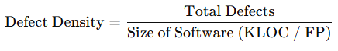
Defect Density=Total DefectsSize of Software (KLOC / FP)\text{Defect Density} = \frac{\text{Total Defects}}{\text{Size of Software (KLOC / FP)}}

🔹 2. Reliability Metrics
# Source: AI Source: Provided by: [Data Path: Persons Table -> ID Column: 1, Name_En Column: Motasem Essam] -> From: [ChatGPT] on [8/21/2025]
- Mean Time Between Failures (MTBF) → Average time between two failures.
- Mean Time To Failure (MTTF) → Expected time to the first failure.
- Defect Leakage → % of defects found by users after release.
  - Formula:
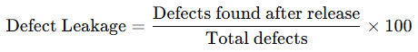
Defect Leakage=Defects found after releaseTotal defects×100\text{Defect Leakage} = \frac{\text{Defects found after release}}{\text{Total defects}} \times 100

🔹 3. Usability Metrics
# Source: AI Source: Provided by: [Data Path: Persons Table -> ID Column: 1, Name_En Column: Motasem Essam] -> From: [ChatGPT] on [8/21/2025]
- User Error Rate → How often users make mistakes while using the software.
- User Satisfaction Score (SUS, CSAT, NPS) → Based on surveys/feedback.
- Task Completion Rate → % of tasks completed successfully by users.

🔹 4. Performance (Efficiency) Metrics
# Source: AI Source: Provided by: [Data Path: Persons Table -> ID Column: 1, Name_En Column: Motasem Essam] -> From: [ChatGPT] on [8/21/2025]
- Response Time → Time taken to process a request.
- Throughput → Number of transactions handled per second.
- Resource Utilization → CPU, memory, bandwidth usage under load.

🔹 5. Maintainability Metrics
# Source: AI Source: Provided by: [Data Path: Persons Table -> ID Column: 1, Name_En Column: Motasem Essam] -> From: [ChatGPT] on [8/21/2025]
- Code Complexity (Cyclomatic Complexity) → Measures how complex the code is.
- Maintainability Index → Score (0–100) showing how easy it is to maintain code.
- Defect Fix Time → Average time to fix defects.

🔹 6. Portability Metrics
# Source: AI Source: Provided by: [Data Path: Persons Table -> ID Column: 1, Name_En Column: Motasem Essam] -> From: [ChatGPT] on [8/21/2025]
- Compatibility Testing Pass Rate → % of environments where software works correctly.
- Platform Coverage → Number of supported OS/devices/browsers.

🔹 7. Security Metrics
# Source: AI Source: Provided by: [Data Path: Persons Table -> ID Column: 1, Name_En Column: Motasem Essam] -> From: [ChatGPT] on [8/21/2025]
- Number of Vulnerabilities found in testing or after release.
- Time to Patch → Time taken to fix a security issue.
- Penetration Testing Success Rate → How many attacks were resisted.

✅ Example in Practice:
# Source: AI Source: Provided by: [Data Path: Persons Table -> ID Column: 1, Name_En Column: Motasem Essam] -> From: [ChatGPT] on [8/21/2025]
Suppose you are testing an E-commerce Website:
- Functionality → 98% of requirements implemented.
- Reliability → MTBF = 20 days, Defect Leakage = 3%.
- Usability → 90% task completion, SUS score = 80/100.
- Performance → Avg response time = 1.2s, throughput = 500 orders/min.
- Security → 2 critical vulnerabilities found and patched in 24 hrs.
This shows the quality status in measurable terms.

👉 In short:
Software quality is measured using metrics like defect density, MTBF, usability scores, performance benchmarks, maintainability index, and security vulnerabilities.

📊 Software Quality Measurement Table
# Source: AI Source: Provided by: [Data Path: Persons Table -> ID Column: 1, Name_En Column: Motasem Essam] -> From: [ChatGPT] on [8/21/2025]
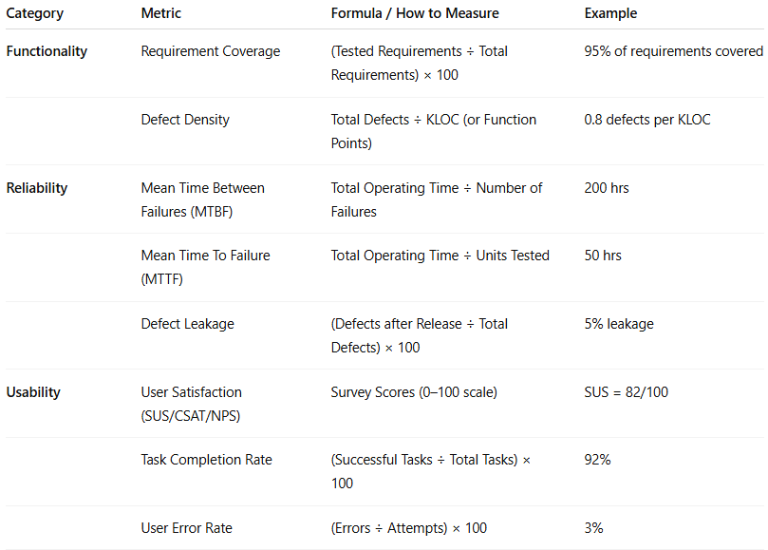
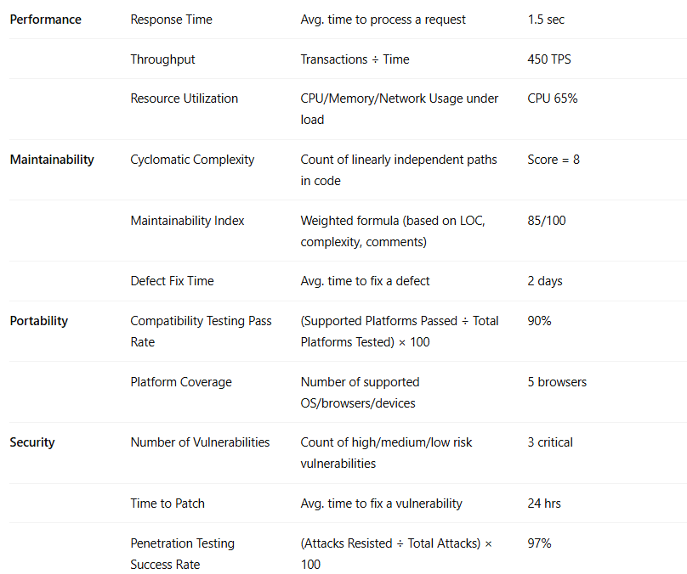

Category | Metric | Formula / How to Measure | Example
Functionality | Requirement Coverage | (Tested Requirements ÷ Total Requirements) × 100 | 95% of requirements covered
 | Defect Density | Total Defects ÷ KLOC (or Function Points) | 0.8 defects per KLOC
Reliability | Mean Time Between Failures (MTBF) | Total Operating Time ÷ Number of Failures | 200 hrs
 | Mean Time To Failure (MTTF) | Total Operating Time ÷ Units Tested | 50 hrs
 | Defect Leakage | (Defects after Release ÷ Total Defects) × 100 | 5% leakage
Usability | User Satisfaction (SUS/CSAT/NPS) | Survey Scores (0–100 scale) | SUS = 82/100
 | Task Completion Rate | (Successful Tasks ÷ Total Tasks) × 100 | 92%
 | User Error Rate | (Errors ÷ Attempts) × 100 | 3%
Performance | Response Time | Avg. time to process a request | 1.5 sec
 | Throughput | Transactions ÷ Time | 450 TPS
 | Resource Utilization | CPU/Memory/Network Usage under load | CPU 65%
Maintainability | Cyclomatic Complexity | Count of linearly independent paths in code | Score = 8
 | Maintainability Index | Weighted formula (based on LOC, complexity, comments) | 85/100
 | Defect Fix Time | Avg. time to fix a defect | 2 days
Portability | Compatibility Testing Pass Rate | (Supported Platforms Passed ÷ Total Platforms Tested) × 100 | 90%
 | Platform Coverage | Number of supported OS/browsers/devices | 5 browsers
Security | Number of Vulnerabilities | Count of high/medium/low risk vulnerabilities | 3 critical
 | Time to Patch | Avg. time to fix a vulnerability | 24 hrs
 | Penetration Testing Success Rate | (Attacks Resisted ÷ Total Attacks) × 100 | 97%

🔍 Software Quality vs Software Testing
# Source: AI Source: Provided by: [Data Path: Persons Table -> ID Column: 1, Name_En Column: Motasem Essam] -> From: [ChatGPT] on [8/21/2025]
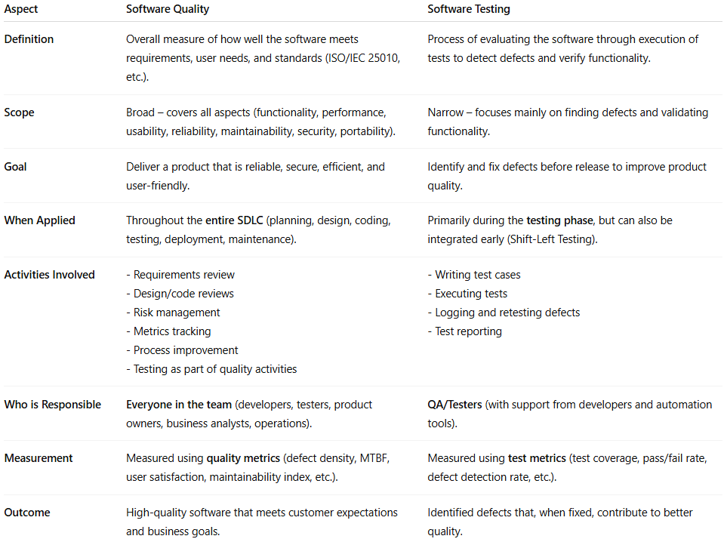
Aspect | Software Quality | Software Testing
Definition | Overall measure of how well the software meets requirements, user needs, and standards (ISO/IEC 25010, etc.). | Process of evaluating the software through execution of tests to detect defects and verify functionality.
Scope | Broad – covers all aspects (functionality, performance, usability, reliability, maintainability, security, portability). | Narrow – focuses mainly on finding defects and validating functionality.
Goal | Deliver a product that is reliable, secure, efficient, and user-friendly. | Identify and fix defects before release to improve product quality.
When Applied | Throughout the entire SDLC (planning, design, coding, testing, deployment, maintenance). | Primarily during the testing phase, but can also be integrated early (Shift-Left Testing).
Activities Involved | - Requirements review- Design/code reviews- Risk management- Metrics tracking- Process improvement- Testing as part of quality activities | - Writing test cases- Executing tests- Logging and retesting defects- Test reporting
Who is Responsible | Everyone in the team (developers, testers, product owners, business analysts, operations). | QA/Testers (with support from developers and automation tools).
Measurement | Measured using quality metrics (defect density, MTBF, user satisfaction, maintainability index, etc.). | Measured using test metrics (test coverage, pass/fail rate, defect detection rate, etc.).
Outcome | High-quality software that meets customer expectations and business goals. | Identified defects that, when fixed, contribute to better quality.

✅ In short:
- Software Quality = the ultimate goal (what we want to achieve).
- Software Testing = one of the key activities to help achieve that goal.

Would you like me to also create a real-world analogy (like comparing it to a car factory – quality = entire car performance, testing = crash tests/inspections) to make it easier to remember?

🔹 Why Software Quality is Important?
# Source: AI Source: Provided by: [Data Path: Persons Table -> ID Column: 1, Name_En Column: Motasem Essam] -> From: [ChatGPT] on [8/21/2025]
- Prevents failures and reduces defects.
- Improves customer satisfaction and trust.
- Saves time and cost in the long run (less rework).
- Ensures compliance with regulations (finance, healthcare, etc.).
- Makes the product competitive in the market.

✅ In summary:
# Source: AI Source: Provided by: [Data Path: Persons Table -> ID Column: 1, Name_En Column: Motasem Essam] -> From: [ChatGPT] on [8/21/2025]
Software quality is about building software that is functional, reliable, secure, efficient, and user-friendly, while also being easy to maintain and adapt over time.

